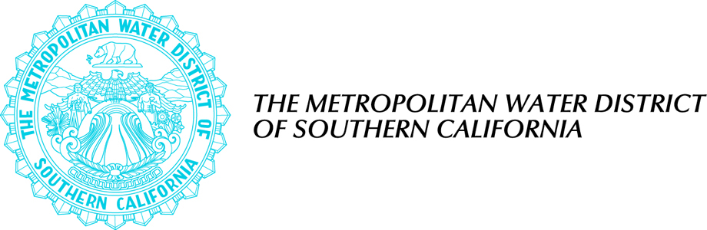

SUMMER STUDENT INTERNSHIP PROGRAM
Co-op Job # 869
Majors: CHE, CE, ME, EE, possibly others

Application Filing Period: February 17, 2010 – March 15, 2010

The Metropolitan Water District of Southern California (MWD) provides water to nearly 19 million Southern Californians. Through an agreement with the Cal Poly Pomona Foundation, Inc. and Cal Poly’s Co-op Education Office, we are currently seeking two (2) talented undergraduate engineering students to participate in our Engineering Services Section Summer Student Internship Program. The program augments the students' studies with practical work experience at MWD.

The Engineering Services Section designs and supervises the construction of water-related structures and facilities, including pipelines, water treatment facilities, operations centers, hydropower plants, reservoirs and numerous regulating structures.

The program is limited to students planning to return to college in the fall of 2010, and is designed to provide only temporary work and a learning work experience in the water industry. All students accepted for this program will end employment by September 30, 2010 (or when the fall quarter/semester starts).

A brief description of available positions is attached.

Classification and Number of Positions: Student Intern -- 2 openings.

Salary: $15.00/hour

Job Duration/Job Location: Work full-time during the summer
[May through September 30, 2010] at our downtown Los Angeles headquarters.

Student Eligibility: Undergraduate students must have a minimum overall GPA of 2.5; at least one year of satisfactory study in engineering and relevant course work needed to perform the duties of the position; and the legal right to work in the United States.

Contact the following for information and to request an application packet:

Cal Poly Co-op Education Office
Kathy Benjamin
kbenjamin@csupomona.edu
(909) 869-3434

Metropolitan Water District
Ruthie Williams
rmwilliams@mwdh2o.com
(213) 217-7654

Completed applications should include: MWD Summer Student Internship Program Application, Summer Student Internship Program Questionnaire and a Schedule Sheet showing availability to interview at MWD’s downtown Los Angeles headquarters during the week of April 12, 2010.

Resumes cannot be substituted for a completed application. A separate and complete application packet must be filed for each position in which you are applying.

The application packet must be completed and received no later than 12:00 Noon on March 15, 2010. Faxes, emails and postmarks NOT accepted. Mail completed packets to:

The Metropolitan Water District of Southern California
700 North Alameda Street
Los Angeles, CA 90012
Attention: Ruthie Williams, Engineering Services Section, Room 3-112

MWD and Cal Poly Pomona Foundation, Inc. proudly promote equal opportunity and diversity in both its employment program and business contracting opportunities.

SummerinternflyerFY1011.doc

SUMMER STUDENTS INTERNSHIP PROGRAM

JOB DESCRIPTION

Job # S1000 - Student Intern - Engineering Services Section, Program Management Unit

Duties: Provide support activities to project managers involved with capital projects and programs. Work activities may include: conducting engineering analyses, preparing written reports, conducting research, analyzing data, preparing spreadsheets and presentations, assisting in the preparation of project schedules and budgets. Some fieldwork will be required.

Desirable Requirements: Currently enrolled in an accredited four year B. S. engineering program (chemical, civil, environmental, mechanical, electrical or similar majors) and must have completed at least two years of study. Knowledge of MS Word, Excel, Power Point, Microsoft Project. Strong analytical skills, effective verbal and written communication skills, knowledge of water treatment plants and facilities, or knowledge of water conveyance and distribution systems, and ability to work productively on multiple assignments.

Work Location: Downtown Los Angeles

SummerStudentsProgramJob DescrFY1011.doc

