Although this conference was rather short, I found it very nourishing for the leadership role that I play at CSUN. For a minority student as myself, it was a privilege to attend this conference as AIMS supported me financially and emotionally. Being at the conference and conversing with different IEEE-HKN SLC officers and members as well as program directors, was very beneficial as it opens my eyes to other leadership methods used by different chapters. We discussed different events held by each chapter and the effect it created on the student population.
Different chapters were very supportive and outspoken about creating a collaborative platform to connect our school to other universities and establish a sense of community. This step is essential in building HKN as future engineers, individually and collectively. I was able to connect with different members from different schools and exchange contacts that will benefit my chapter in different matters. Our events can be further enhanced with some experience from other chapters and vice versa.
This conference not only helped me build connections with other chapters, it helped me learn about the role of my chapter more closely. As our previous officers have strived for better society, we, the current officers, have to strive further in establishing our presence at the University. I was honored to be called out for an award of an outstanding chapter. This was very warm for us as we felt the responsibility we hold today to carry on the successful path that was laid before us.
In the end, it was a pleasant weekend, we gain a lot of friends and knowledge about our Society. We made connections and created a community that extends our efforts in further advancing CSUN and our Lambda Beta chapter. I would take many things from this conference, but the most valuable lesson I learned is community is everything, and AIMS is the reason for that. I would like to thank AIMS for giving me the chance to attend this conference, specifically AIMS director Dr. S. K. Ramesh. Dr. Ramesh support did not end with the traveling expenses but rather extended to include a very welcoming colleagues who attended the conference. Our trip would have not been possible without Dr. Ramesh and AIMS support.

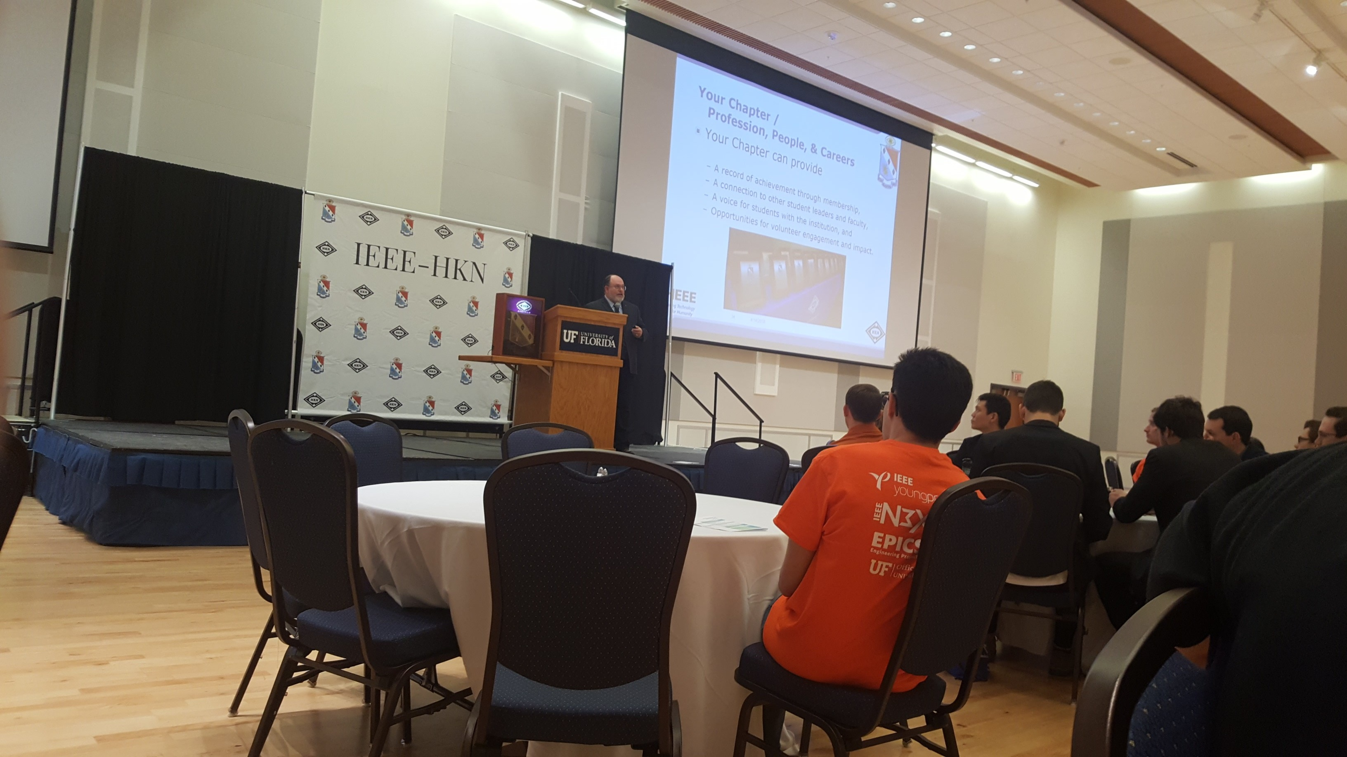
HKN president Steve E. Watkins Addressing conference attendees on the importance of community in EE.
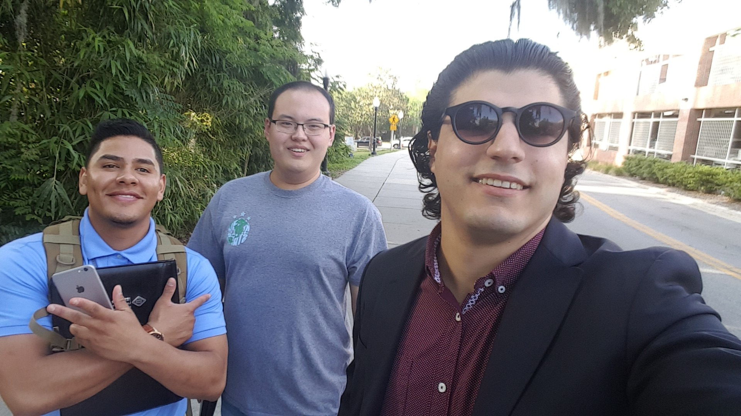
Josue Galeno, Xiaoao Feng, and Myself (Hareth Abdalkarim), on the way to the conference (First day).
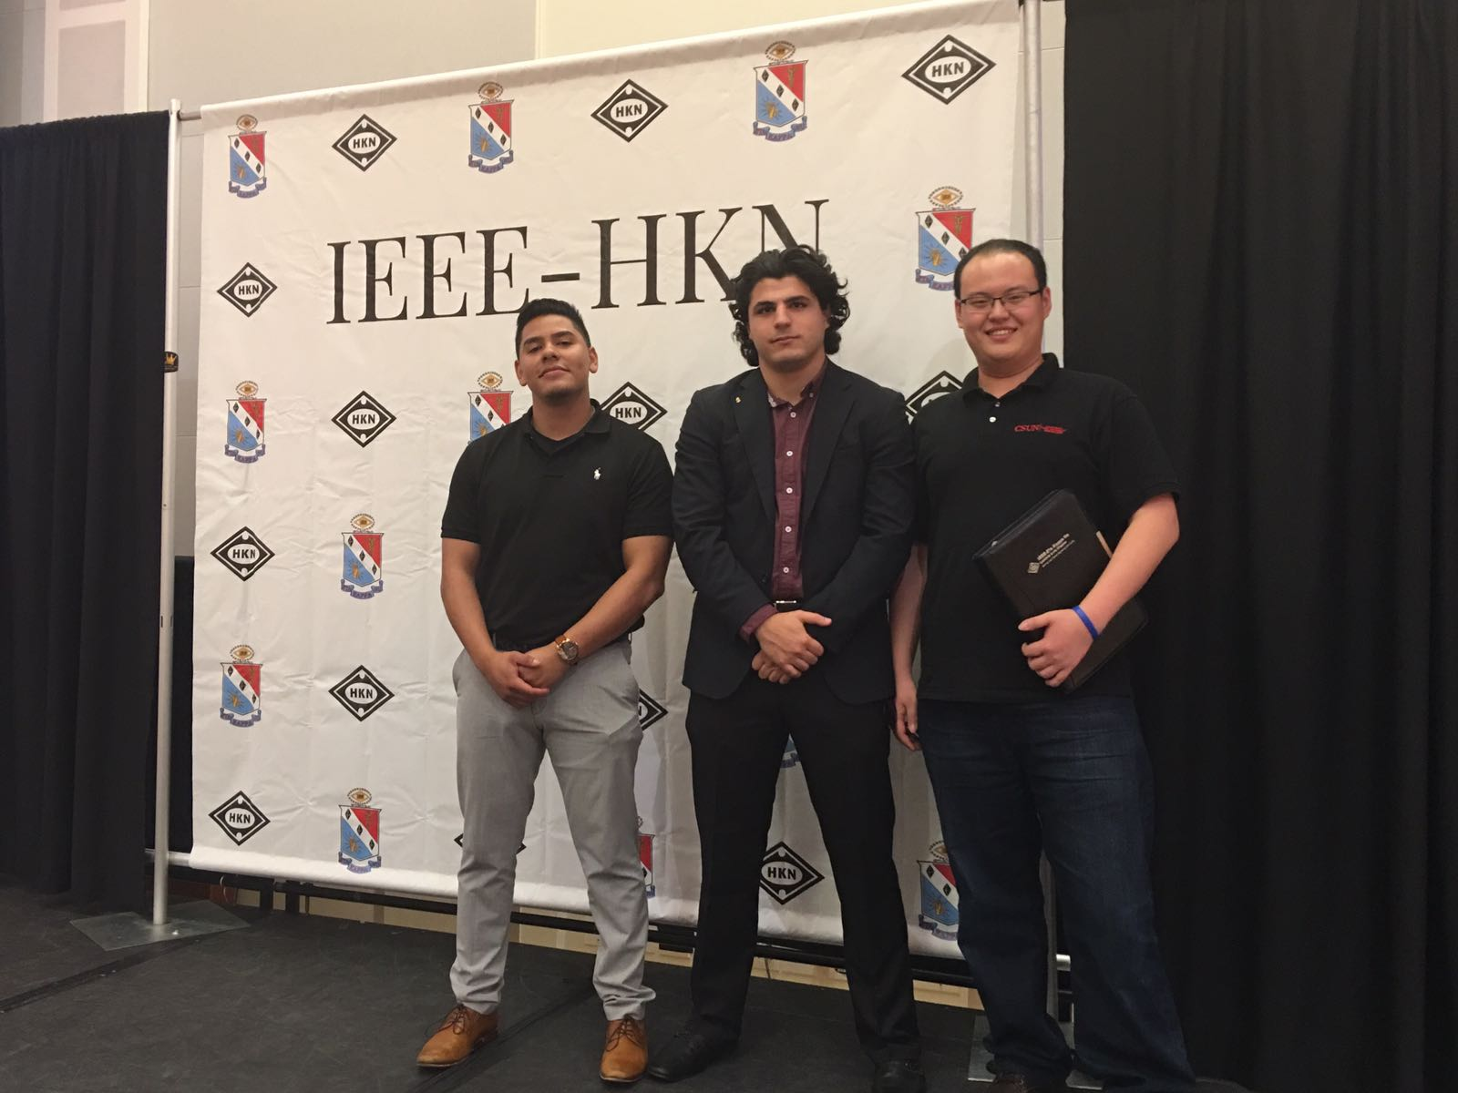
Josue Galeno, Myself (Hareth Abdalkarim), and Xiaoao Feng, posing for team photo (second day).
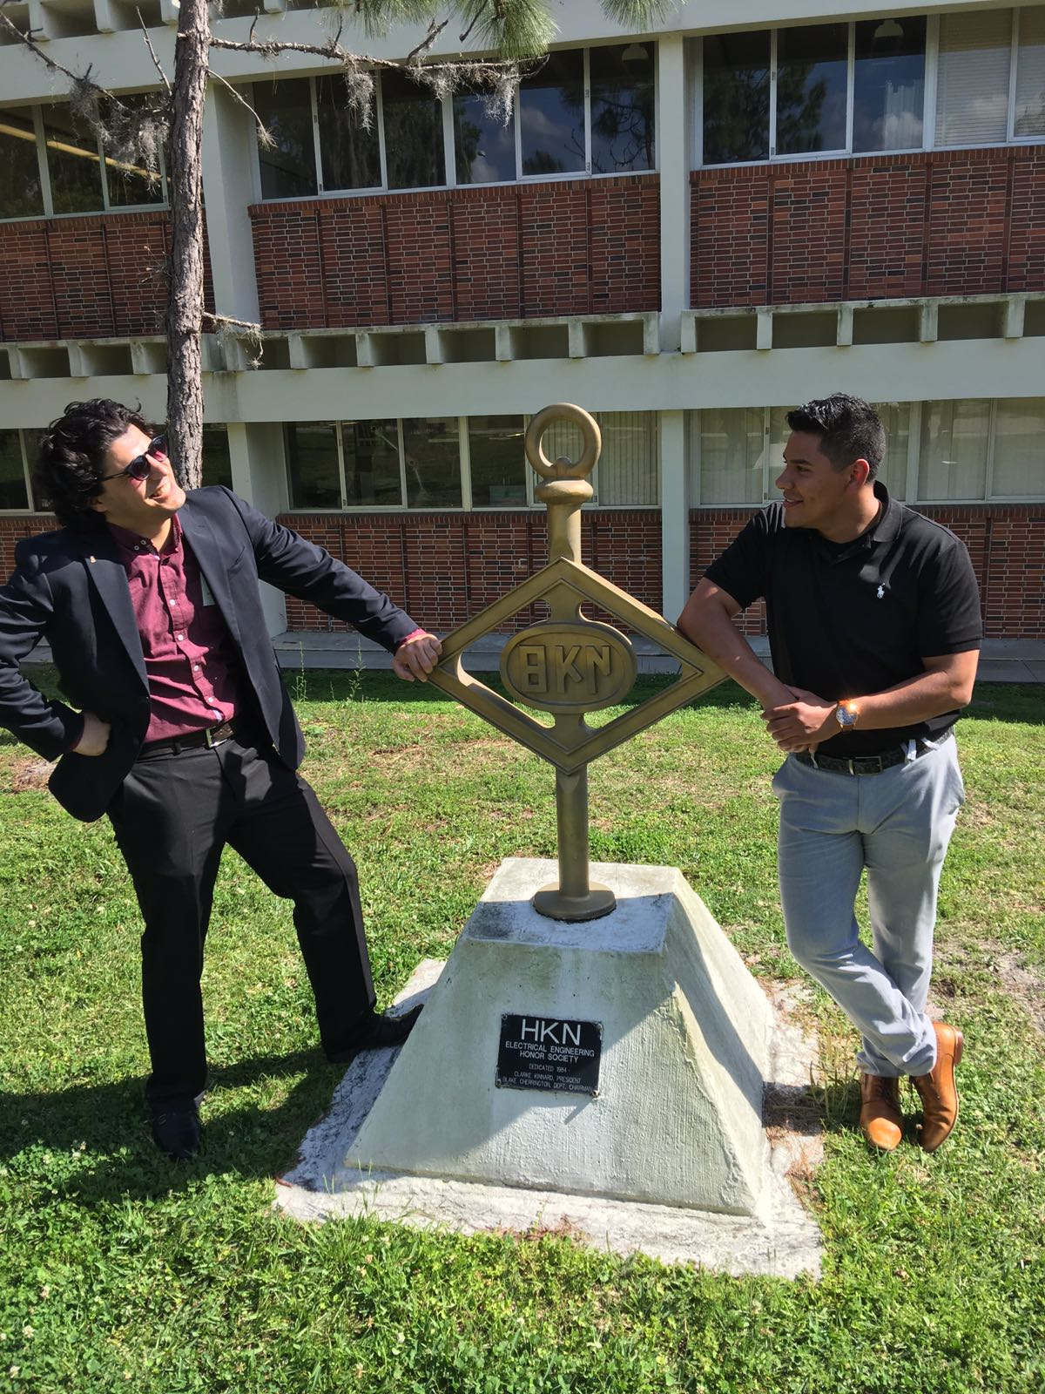
Myself (Hareth Abdalkarim) with Josue Galeno, posing by the HKN monument at the University of Florida (Second day)

