Software Requirements Specification
for

Fun E-Learning Platform System
(FeLPS)
Version 1.0.0
Prepared by Yelena Bederman, Eric Driggs,
Himanshu Sharma, Nikolas Terani

17 December, 2009

Table of Contents

Fun E-Learning Platform System (FeLPS) 1
Table of Contents 2
Revision History 4
1. Introduction 1
1.1 Purpose 1
1.2 Project Scope, Project Vision and Product Features 1
1.2.1 Scope 1
1.2.2 Background, Business Opportunity, and Customer Needs 1
1.2.3 Business Objectives and Success Criteria 2
1.2.4 Business Risks 2
1.2.5 Assumptions and Dependencies 2
1.2.6 Stakeholder Profiles 3
1.2.7 Project Priorities 3
2. Overall Description 4
2.1 Product Perspective 4
3. System Features 5
3.1. Course Management 5
3.1.1 Course Management: Priority and Description 5
3.1.2 Course Management: Stimulus and Response 6
3.1.3 Course Management: Functional Requirements 6
3.2 Collaboration 7
3.2.1 Collaboration: Priority and Description 7
3.2.2 Collaboration: Stimulus/Response Sequences 9
3.2.3 Collaboration: Functional Requirements 10
3.3 Administration 11
3.3.1 Administration: Priority and Description 11
3.3.2 Administration: Stimulus/Response Sequences 12
3.3.2 Administration: Functional Requirements 13
3.4 User management 14
3.4.1 User Management: Priority and Description 14
3.4.2 User Management: Stimulus/Response Sequences 14
3.4.3 User Management: Functional Requirements 15
3.5 Knowledge delivery 16
3.5.1 Knowledge Delivery: Priority and Description 16
3.5.2 Knowledge Delivery: Stimulus/Response Sequences 16
3.5.3 Knowledge Delivery: Functional Requirements 16
3.6 Find a course 17
3.6.1 Find a Course: Priority and Description 17
3.6.2 Find a Course: Stimulus/Response Sequences 17
3.6.3 Find a Course: Functional Requirements 18
3.7 Revenue Generation 18
3.7.1 Revenue Generation: Priority and Description 18
3.7.2 Revenue Generation: Stimulus/Response Sequences 18
3.7.3 Revenue Generation: Functional Requirements 18
3.7 Help 19
4. Sysml Diagrams 19
4.1 Block Diagram 20
4.2 User Roles 22
4.3 Use Case and Activity Diagrams 22
4.3.1 Use cases for User Role 23
4.3.2 Use Cases for Owner Role 28
4.3.3 Use Cases for Administrator Role 30
5. Trade study 32
5.1 Drupal 32
5.1.1 Overview 32
5.1.2 Features 32
5.1.3 Experiment 32
5.2 Modular Object-Oriented Dynamic Learning Environment (Moodle) 33
5.2.1 Overview 33
5.2.2 Features 33
5.2.3 Experiment 33
5.3 Commercial Alternatives 34
6. Non-functional requirements 35
6.1 Performance 35
6.2 Security 35
6.3 Usability & Accessibility 35
6.4 Scalability 35
6.5 Maintainability 35

Revision History
Name | Date | Reason For Changes | Version
Eric Driggs and Nikolas Terani | 11/30/09 | Initial outline and topic headings. Sections assigned to each class member. | 0.1.0
Yelena Bederman, Nikolas Terani, Eric Driggs, Himanshu Parva | 12/04/09 | Initial draft for Yelena’s sections: Introduction, User Management, Knowledge Delivery and multiple use cases. Team reviewed Yelena’s contributions and Nikolas’ Collaboration section. SRS format was refined, with each section getting Stimulus/Response. | 0.1.1
Nikolas Terani | 12/07/09 | Merged Nikolas and Eric’s sections into group document. Nikolas did Collaboration, block diagram, and activity diagrams. Nikolas revised his feature elaboration which is serving the team as a high-level SRS. Eric did Administration and Revenue Generation. | 0.1.2
Eric Driggs | 12/07/09 | Changed versioning from 1.0 to 0.1 (1.0 is the submitted version), multitude of formatting changes, including changing all non-heading text to style normal, unified indentation and transferred all priorities and functional requirements to tables. | 0.1.3
Nikolas Terani | 12/11/09 | Added descriptions for course management and edited collaboration. | 0.1.4
Yelena Bederman | 12/11/09 | Added “Modify Course” use case | 0.1.5
Eric Driggs | 12/11/09 | Added use case diagrams. Added Delete course use case. Removed unnecessary use cases from user management. | 0.1.6
Eric Driggs, Nikolas Terani, Yelena Bederman | 12/11/09 | Added Nikolas’ updated block diagram. Added ToDo comments for pending sections. | 0.1.7
Eric Driggs, Nikolas Terani and Himanshu Sharma | 12/17/09 | Group meeting to merge Himanshu’s contributions on Course Management and Overview. | 0.1.8
Eric Driggs and Nikolas Terani | 12/17/09 | Another meeting to create non-functional requirements and implement help system | 0.1.9
Eric Driggs | 12/17/09 | Added trade study and made final corrections | 0.2.0
Nikolas Terani | 12/17/09 | Added context diagram and MyLibrary. | 0.3.0
Nikolas Terani | 12/17/09 | Final Edit | 1.0.0
Eric Driggs | 12/17/09 | Fixed Typo | 1.0.1

Introduction

Purpose
This SRS describes the software functional and nonfunctional requirements for release 1.0 of the Fun E-learning Platform System (FeLPS). This document is intended to be used by the members of the project team that will implement and verify the correct functioning of the system. Unless otherwise noted, all requirements specified here are high priorities and committed for release 1.0.

Project Scope, Project Vision and Product Features
The Fun E-Learning Platform System will permit website users to create and take courses, to socialize and collaborate with each other.

Scope
Feature | Feature name | Release 1
FE-1 | Course Management | Fully implemented
FE-2 | Collaboration | Fully implemented
FE-3 | Administration | Fully implemented
FE-4 | User Management | Fully implemented
FE-5 | Knowledge Delivery | Fully implemented
FE-6 | Find A Course | Fully implemented
FE-7 | Revenue Generation | Fully implemented
FE-8 | Help | Fully implemented

Background, Business Opportunity, and Customer Needs
The reasoning behind the vision:
- Taking advantage of user contributed content and open course learning
- Any learning site should allow users to enter original content.
- It is not always necessary to generate original content for courses. Many free courses already exist on the internet, and these may be incorporated into the site through:
  - External links to free textbooks
  - External links to courses (resources)
  - Internal quizzes for external books and courses
  - Internal lesson plans for external books and courses.

- E-learning can provide intrinsic and extrinsic motivations for learners.
  - Extrinsic motivations:
    - Quiz Scores
    - User Profiles showing which courses they have studied and completed.

  - Intrinsic motivations
    - Learning new material.
    - Understanding school classes better.
    - Improving skills for professional advancement
    - Helping others
    - Games
    - Interesting user discussion.

The target markets include:
- working professionals
- elementary school teachers
- high school teachers
- college professors
- students from high school age upwards
- anyone with a passion for learning new subjects

The problems which the site attempts to solve are:
- Where can I find free courses, text books, quizzes and forums for a wide range of learning subjects?
- How to use e-learning to help motivated people overcome learn new material?
- How can e-learning content from any free site on the internet be integrated organically into one e-learning site?
- How can many subjects be organized in a way such that a particular subject is easily found, but where users are not overwhelmed with options?

Business Objectives and Success Criteria
BO-1: Get large population of users
BO-2: Get sponsors/clients

SC-1: 100,000 registered users within 6 months
SC-2: 40,000 active users by month 6 (active users defined as those who log in the website at least 10 times per month)

Business Risks
RI-1: Sponsors may not be interested in FeLPS
RI-2: Competition from similar websites
RI-3: Low ad revenue generation

Assumptions and Dependencies
AS-1: User has at least dial-up internet connection
DE-1: Web server must be available for website to function
DE-2: Space is available on the web server to upload files and create courses

Stakeholder Profiles
Stakeholder | Major Value | Attitudes | Major Interests | Constraints
Management | Organizing the team; manage the project | strong commitment through release; support for release | revenue in 1st year must exceed development costs | Schedule, Budget, Human resources
FeLPS Users | Generate Ad revenue; referrals | Collaboration with each other; help others; self motivation and desire to learn | Get Accurate Knowledge | Role dependent
Sponsors | Revenue source | Business minded | Promote a product/service through FeLPS | FeLPS rejection of ad
Project Team | Develop and maintain the FeLPS | Commitment to product | Develop and maintain a high quality product on time and within budget | Schedule, budget, resources and expertise

Project Priorities
Dimension | Driver | Constraint | Degree of Freedom
Schedule |  |  | release 1 by 06/01/2010; up to 3 weeks delay acceptable
Features |  | All features scheduled for release 1.0 must be fully operational
Quality |  | 95% of user acceptance tests must pass; all security tests must pass; compliance with corporate security standards must be demonstrated for all payment transactions
Staff | projected team size is project manager, 2 developers, designer and tester; additional half-time developer and half-time tester will be available if necessary
Cost |  |  | budget overrun up to 5% acceptable

2. Overall Description

2.1 Product Perspective
The Fun e-Learning Platform is a unique, user-content driven system which is designed to provide e-learning with collaboration. This system provides its users the ability to take non-academic courses on any topics that they are interested in. FELPS aggregates knowledge from all over the web into one portal. One of the goals in FELPS is to use loosely-coupled subsystems so off-the-shelf software components can be used.

2.2 User Characteristics

The users can be classified into the following categories:-

- Administrators: They are responsible for 1) the maintenance of the website, 2) enforcing the terms of service and 3) providing e-mail support to users.

- Course Owners: These are the users who create a course. They should have expertise on the subject and have relevant content which can help others to learn more on that course. They also have the privilege to promote or demote members for their course to the status of a moderator for their course. They can also suspend or resume a course.

- Moderators: These are the users who take some load off the course owners in terms of content control. They also have certain privileges using which they can suspend a course and submit a request to the administrators to perform the necessary action. They can also remove users from the group, delete inappropriate content uploaded by the members (they cannot edit Course material).

- Users: These are the users who log onto the FeLPS system and search for their desired courses and enroll in them. The primary users of FeLPS consist of students ranging from grade schools to graduate level, working professionals, or anyone with a desire to learn new things using self-paced learning.

System Features

3.1. Course Management

Course Management: Priority and Description
Priority: | High

Course Creation
Priority: | High

Any registered user can create a course. The creator of the course becomes the course owner. A course can be deemed private or public. Any registered user can become a course member of a public course. To join a private course you must be invited by the private course owner. A collection of course members can effectively form a group within a course by creating a private group. This gives them all the collaboration tools provided by courses for conducting group activities.

Course Moderation
Priority: | High

Course management: courses are managed in two ways: owners and moderators. A course owner is the individual who created the course. This individual has the right to add and remove content associated with the course. Course owners can also ban users from the course. Course owners can promote a class member to moderator. The moderator then has all the privileges of the course owner except the ability to edit course owner content or the course home page.

Course Agenda
Priority: | Low

Course agenda/sequence: the course agenda is the sequence of activities for the course laid out over an appropriate time line. This agenda helps the student stay on task.

Course Profile (not to be included in this version)
Priority: | N/A

The course profile provides a snapshot of important course statistics to prospective course members. The statistics would include active course members, total course members, course rating, and course reviews.

Course Management: Stimulus and Response

Course Creation
Stimulus: User executes create course function through UI
Response: The system provides the form for course creation

Stimulus: User fills out the form and submits
Response: The system checks if form is filled out completely and asks for confirmation

Stimulus: User confirms
Response: The system creates a course

Moderation

Stimulus: Course’s owner goes to course management page
Response: The system opens the course management page with available tools

Stimulus: Course’s owner chooses activity (update, upload, etc)
Response: The system opens the page with that activity

Stimulus: Course’s owner does activity
Response: The system does updates

Agenda
Stimulus: Course owner edits course agenda.
Response: Agenda for course is updated.

Profile (Not included in this version)
Stimulus: Number of course members changes.
Response: Course profile statistics are updated to reflect number of members.

Stimulus: Course member visits course
Response: Course profile statistics for active members is updated.

Course Management: Functional Requirements

Course Management: Creation

Function | The system shall:
CreateCourse | allow user to create a course
Create.Course.Form | Provide a form with required course fields
Create.Course.Location | Require user to choose location for new course
Create.Course.Private | allow user to choose type of course (public/private). Any FELPS user can join a public course, but needs owner approval to join a private one.
Create.Course.UpdateCatalog | update the catalog with the newly created course

Course Management: Modify
Function | The system shall:
Modify.CourseContent | Allow owner to make changes to course content.
Modify.Private | Allow owner to change whether a course is public or private.

Course Management: Agenda/Sequence

Function | The system shall:
Agenda.Create | provide the ability to create an agenda for the course.
Agenda.Edit | provide the ability to edit an agenda for the course.

Course Management: Membership
Function | The system shall:
Member.Promote | Allow owners to promote other users to course moderator status.
Member.Demote | Allow owners to remove course moderator status from users in their course.
Member.Ban | Allow owners to ban moderators and members from the course, and moderators to ban course members.

Collaboration

Collaboration: Priority and Description
Priority: | High

We want to take advantage of the social networking phenomenon. A great resource for any student is fellow students. The collaboration tools aim to provide a natural way for students to share information with one another. Within this course home page you will find some of the collaboration tools. For these tools to be useful there will have to be many students taking the course at any given time. It is not realistic to expect past students to be spending their time in courses they have already completed. It would also seem natural to provide some of the collaboration tools at the subject level instead of the course level. This will create a wider audience and a natural way for “teachers” to help students with subject matter. If courses with externally provided resources do not have teachers in most incidences then do we need to organize students based on the degree to which they have completed the course? This assumes students are starting the course material at different times and completing the course work at different paces. Do we need to help them organize students to help make collaboration more effective or do we simply allow for collaboration to take place and wait for an answer to be given by the appropriate student?

Uploading files to a course
Priority: | High

Uploading files within a course: you want a way for course members to be able to share files. Therefore every time you take a course you become member of the course. Members of the course will have the ability to share documents. FeLPS should provide the ability to form private groups within a course for secure file sharing.

Chat
Priority: | Medium

Chat: this is a well known feature that doesn’t need explanation other than where it will reside. The chat rooms will reside within the course page and the subject page. The course chat will be a vehicle for people to discuss subject matter directly. Where the subject chat will serve more of a social function where people can find other people who are interested in the same subject matter or ask questions.

Blogs
Priority: | Medium

Blogs will be at the subject level. This is where individuals can blog about subject matter.

Forums
Priority: | High

Forums will be hosted at the subject and course level. Here students can make post and other students and or “teachers” can respond to questions. By conducting the forums at the subject level they receive more visibility and a result, hopefully, have more utility. Subject level forums will also be viewable from every course that resides within that subject. Every course will also contain a forum. This forum will be a place where members of the course can post and answer questions. The course member will have the ability to make the query at the course forum public. This means that the query will propagate automatically to the subject level within which the course resides.

Conferencing (Not provided in this version)
Priority: | N/A

Conferencing: conferencing is something that will be put off till a future release. This will mimic WebEx and other conferencing tools that allow for real time meetings. The idea would be for teachers to have a platform to conduct real time lectures. It also could be helpful for virtual study sessions for students. Low cost video and white boards are potential implementations.

Collaboration: Stimulus/Response Sequences

File Sharing

Stimulus: User clicks on upload file
Response: System takes user to user uploaded files directory

Stimulus: User selects folder to place file in
Response: System saves location for uploaded file

Stimulus: User clicks on browse button
Response: System displays user’s file directory

Stimulus: User clicks on file to upload
Response: System displays file in upload box

Stimulus: User clicks on upload button
Response: System displays file in user selected folder

Chat

Stimulus: User clicks on chat
Response: System displays all logged in users in course or subject

Stimulus: User selects user to chat with
Response: System opens a chat window

Stimulus: User types in message and submits
Response: System sends message

Stimulus: User clicks close chat
Response: System closes chat window

Blogs

Stimulus: User clicks create a block at the subject level
Response: System opens create a blog form

Stimulus: User fills out blog form and clicks submit
Response: System validates blog has been created

Stimulus: User clicks edit blog
Response: System validates user is owner of blog
Response: If owner system displays blog edit form (If not owner system denies access)
Stimulus: User writes new blog and clicks post
Response: System commits blog and validates edit.

Create Forum Topic at Subject Level

Stimulus: User clicks post topic
Response: System validates user is logged in
Response: If logged in system opens post topic form. (If no system asks user to log in)

Stimulus: User fills out form and clicks post topic
Response: System commits topic and returns user to subject forum where new topic has been placed

Create Forum Topic at Course Level

Stimulus: User clicks post topic
Response: System validates user is logged in
Response: If logged in system opens post topic form. (If no system asks user to log in)

Stimulus: User fills out form and clicks post topic
Response: System commits topic and returns user to course forum where new topic has been placed

Responses to Forums at Subject Level and Course Level

Stimulus: User clicks on forum topic
Response: System validates user is logged in
Response: If logged in system opens topic page with user replies. (If no system asks user to log in)

Stimulus: User either clicks post reply
Response: System takes user to the reply form

Stimulus User fills in reply and clicks post
Response: System commits reply and returns user to topic reply page

Conferencing (not included in this version)

Collaboration: Functional Requirements
(Collaboration abbreviated to C. in tables below:)

Collaboration: File Sharing, Functional Requirements
Function | The system shall:
C.FileSharing | permit users to upload files to any course they are enrolled in.
C.File.Sharing.Format | only allow text based files to be uploaded.
C.File.Sharing.Size | Limit the size of the file to two megabytes.

Collaboration: Chat

Function | The system shall:
C.Chat: | provide a mechanism for chatting between any logged in users of the system. The functionality will be provided by Druple and or vBulletin
C.Chat.Course: | provide a chat room for every course hereto referred to as "course chat room".
C.Chat.Subject: | provide a chat room for every subject hereto known as "subject chat room"

Collaboration: Blogs

Function | The system shall:
C.Blogs | provide the ability for logged in users to create blogs at the subject level. This functionality will be provided by Druple and or vBulletin

Collaboration: Forum

Function | The system shall:
C.Forum: | provide forums at the course and subject level. This functionality will be provided by Druple and or vBulletin
C.Forum.Course | provide forums at the course level
C.Forum.Course.Use | only allow course members to use the forum
C.Forum.Subject | provide forums at the subject level
C.Forum.Subject.Use | allow any logged in user to use the subject forum

Administration

Administration: Priority and Description
Administrators can act as Course owners for any course, and have the additional abilities to delete courses, suspend or resume user accounts, and add games and applications to subject pages. Their role as site-wide moderators is essential to ensure a positive user experience, but their role is mainly reactive in responding to user support issues.

3.3.1.2 Administrator Moderation
Priority: | High

Administrators respond to user support issues and copyright claims. They have the ability to act as owners, moderators or members for any course. Their responsibilities include removing abandoned or inappropriate courses and files which violate copyright. Most Administrator tasks are in response to user-submitted email support requests. Only Administrators can remove courses and suspend users.

3.3.1.3 Administration of Games and Applications
Priority: | Low

Games and Web Applications can be written several languages including but not limited to JavaScript, Java and Flash. Due to security concerns, course moderators can add hyperlinks in course libraries or course home pages to any web address, including external games and applications. However, only Administrators have the ability to upload games and applications to the FELPS server or add the code necessary to embed external games and applications in a subject web page.

3.3.2 Administration: Stimulus/Response Sequences

3.3.2.1 Administrator Moderation

3.3.2.1.1 Owner Violations
Stimulus: Administrator is assigned support issue related to course owner violating FELPS policy, e.g. owner uploaded obscene material or unsolicited commercial advertisements unrelated to learning.

Response: Administrator makes determination if the course owner violated FELPS policy in bad faith. If so, the course is deleted and a warning email is sent to the course owner. The Administrator then has the option to suspend the course owner’s account. If course does not violate FELPS policy, response is sent to email of user who submitted support issue stating course was found to not violate FELPS policy.

3.3.2.1.2 Content Violations

Stimulus: Administrator is assigned support issue related to content violating FELPS policy, e.g. copyright infringement or obscene material.

Response: Administrator removes the infringing content. This could be a forum post, file, blog entry or any other content contained in the FELPS site. Email is sent to users who uploaded or created content, notifying user that the content has been removed for a policy violation.

3.3.2.1.3 User Conduct

Stimulus: Administrator is assigned support issue related to user violating FELPS terms of service, e.g. harassment users or attempting to disrupt normal use of site.

Response: Administrator determines if user has violated terms of services, if so Administrator has option to warn user or suspend user account.

3.3.2.1.4 Automated Cleanup of Abandoned Courses

Stimulus: FELPS system runs monthly script to clean up abandoned courses.

Response: If no course members has visited course page for at least 9 months but less than a year, warning email is sent to course owners and moderators stating course will be removed if there is no activity for 1 year. If course has been inactive for 1 year, it is deleted.

3.3.2.1.1 Missing Owners and Moderators

Stimulus: Administrator receives support issue relating to abandoned course, i.e. owner and moderator is unresponsive.

Response: If owner or moderator has not visited course page for 6 months, email is sent to owner and moderators. If owner or moderator does not visit page or respond to email within two weeks, Administrator holds forum vote for new course owner. The top ten most active users for the course are listed in the poll

3.3.2.2 Administration of Games and Applications

3.3.2.2.1 Admin Programs for Subjects
Stimulus: Admin uploads embedded program (game or application) for a FELPS subject.
Response: FELPS subject lists game on subject page.

3.3.2.2.2 Display Subject Program
Stimulus: User clicks on link to embedded game or application
Response: FELPS displays page with embedded game or application.

3.3.2.2.3 Display Hyperlink Program
Stimulus: User clicks on owner/moderator hyperlink which may point to an existing program on FELPS or another site.
Response: Browser displays web page, which may contain a program.

Administration: Functional Requirements

3.3.2.1 Administrator Moderation Functional Requirements
Function | Performs
RemoveCourse: | Admin deletes course from FELPS, including course forums, course home page and all uploaded files.
RemoveContent: | Admin removes content from FELPS.
SuspendUserAccount: | Admin suspends user from all of FELPS. Suspended users cannot log in to FELPS and lose owner and moderator status for all courses.
ResumeUserAccount: | Admin un-suspends user from FELPS. User can now log in to FELPS and is a member for all courses he belonged to when suspended.
PromoteCourseMember: | Administrator gives course member moderator or owner status.
DemoteCourseMember | Administrator removes moderator status for course member moderator or owner.
ReceiveReport | Administrator receives user support issue.
SendUserMessage | Administrator sends user a message through email.

3.3.2.2 Administrator Games and Applications Requirements

Function | Performs
UploadSubjectProgram: | Admin uploads program to FELPS subject page.
DeleteSubjectProgram: | Admin removes program from FELPS subject page.
DisplaySubjectProgram: | FELPS displays embedded program when link on subject page is clicked.

User management

User Management: Priority and Description
Priority: | High

User management consists of the tools that are provided to enhance the user experience and help the students facilitate learning. Tools include:
  - Registration: the user has the ability to register to become a member of the site.
  - Enrollment: the user has the ability to enroll in a course and become a course member.
  - Customization of user preferences: The user has the ability to customize the user interface. This allows for changing the appearance of the site from layout to colors.
  - User profile: The user has the ability to set up a profile containing demographics and contact information.
  - Planner: The planner helps the student manage course activities. Since this is self-study the planner should allow for the student to set his own time frame for completing the course irrespective of the course schedule.
  - MyLibrary: Every user will have a customized library. This library is a collection of educational material that has been uploaded to the site by course members and course owners. The library is customized in the sense that every user has a different library. The library is all the reference material that has been uploaded to the site in relation to the courses that the individual is taking or has taken (both by course owners and members). The idea here is that individuals spend a lot of time locating valuable articles when they research a subject matter. We want to capture that effort by allowing them to upload material they have deemed valuable to the course. Users will be able to edit their MyLibrary.

User Management: Stimulus/Response Sequences

Registration
Stimulus: User clicks on registration link
Response: System provides a registration form

Stimulus: User fills out the form
Response: System sends confirmation to user’s email

Stimulus: User confirm registration
Response: System activates log in

Enrollment
Stimulus: User clicks on enrollment link
Response: System enrolls user in the course

Customization
Stimulus: User clicks on profile customization link
Response: System provides list of areas for customization

Stimulus: User chooses area
Response: System provides available options for this area

Stimulus: User makes changes
Response: System saves changes

Profile
Stimulus: User clicks on profile update link
Response: System provides areas for updating

Stimulus: User chooses area
Response: System opens this area for updating

Stimulus: User makes changes
Response: System saves changes

History
Stimulus: User does some activities
Response: System puts the recent activity in history, removes the oldest one

Planer
Stimulus: User makes schedule
Response: System saves schedules and sends reminders to the user

User Management: Functional Requirements

Function: | The system shall:
UserM: | provide user with user’s management tools.
UserM.Email: | have an ability to communicate with the users through email.
UserM.Registration: | allow new user to register.
UserM.Registration.Username: | require Usernames to be distinct.
UserM.Registration.email: | not allow one email address be registered more than once. If email is already in Data Base notify the user about that, and ask if he/she wants to login.
UserM.Registration.Confirmation: | send a confirmation to the email provided in 2 minutes.
UserM.Registration.Activation: | activate a User's account after confirmation is completed.
UserM.Registration.NotConfirmed: | remove an account if it’s not activated in 24 hours.
UserM.Login: | provide a login field for user.
UserM.Login.Password: | be able to reset and send out a password if user forgets it.
UserM.Login.Username: | be able to send on provided email a username if user forgets it.
UserM.Enroll: | allow user to enroll in the course.
UserM.Drop: | allow user to drop the course.
UserM.Profile: | force a user to create basic profile.
UserM.Profile.Edit: | allow user to update his/her profile.
UserM.Profile.Edit.Password: | allow user to change a password.
UserM.Profile.Edit.email: | allow user to change email.
UserM.Profile.Edit.Username: | not allow user to change a username.
UserM.Customization: | allow user to customize his/her home page.
UserM.Cutomization: | have options for customization.
UserM.Customization.Confirm: | ask user if he/she is sure about those changes before applying them.
UserM.Customization.Save: | save all customization changes.
UserM.History: | remember last 10 activities that user did.
Userm.History.Show: | have a space to show user’s recent activities.
UserM.Planner: | provide a planner for user.
UserM.Planner.Edit | update planner after each change.
UserM.Planner.Notify: | send/show a reminder to the user.
UserM.MyLibrary | Aggregate all the courses’ content that a user is a member of into one location.
UserM.MyLibrary.Content | Aggregated content shall be separated into course owner content and user content

Knowledge delivery

Knowledge Delivery: Priority and Description
Priority: | High

Knowledge delivery pertains to entities used to educate the users of the site. The entities chosen to deliver knowledge are: courses (external and internal), quizzes, interactive learning games, and library.

Knowledge Delivery: Stimulus/Response Sequences
Stimulus: User clicks on course link
Response: System gets user to the course web page
Stimulus: User chooses activity
Response: System provides that activity
Stimulus: User finishing the activity
Response: System updates the user’s progress

Knowledge Delivery: Functional Requirements
Function: | The system shall:
ViewCourse: | let a user or visitor view the course webpage.
ViewCourse.Material: | allow only logged in users who enrolled in course to view course material and participate in collaboration.
ViewCourse.AccessFile: | provide presentations, video and other files with information, articles and other materials that needed for student to learn this course.
ViewCourse.ViewLink: | list external links with related information for this course and shall open new window with correct url address when user clicks on the link.
ViewCourse.Quiz: | allow user to take a quiz/test for the course.
ViewCourse.Quiz.Result: | provide user with correct result on the quiz and record it.
ViewCourse.Application: | show available educational applications related to this subject and shall allow user to use chosen application.
ViewCourse.Notification: | notify the user about any changes in the course.
ViewCourse.Save: | allow user to save and resume quizzes.

Find a course

Find a Course: Priority and Description
Priority | High

It is critical to develop an effective way for users to connect to courses. There are two primary methods to locate courses: search and catalog. Search – is uses a search text box and search engine to find courses. Catalog – is the ability to find a course by theme, topic, or name.

Find a Course: Stimulus/Response Sequences

Search
Stimulus: User types keyword in the search box
Response: System searches for courses and list them

Stimulus: User chooses a course
Response: System redirects to the course home page

Stimulus: User tries to access course material
Response: System asks user to enroll in the course

Catalog
Stimulus: User clicks on catalog
Response: System provides topics

Stimulus: User chooses topic
Response: System provides subtopics

Stimulus: User chooses a course
Response: System redirects to the course home page

Stimulus: User tries to access course material
Response: System asks user to enroll in the course

Find a Course: Functional Requirements
Function: | The system shall:
FindCourse: | let a user to find a course using either search or catalog options.
FindCourse.Search: | look for course based on keyword in the search box.
FindCourse.Search.Result: | list all courses related to the keyword.
FindCourse.Search.NoResult: | notify the admin that there is a demand for courses related to that keyword and shall ask user to redefine the search.
FindCourse.Catalog: | have a hierarchy of all courses in the catalog from category to subjects to courses.
FindCourse.Choose: | redirect user to the correct course webpage after user chooses the course.

3.7 Revenue Generation

3.7.1 Revenue Generation: Priority and Description

Priority: | High
FELPS’ primary source of revenue is through advertisements on every page of the FELPS website. FELPS programmers have the responsibility of creating and modifying Advertising Units within the Advertisement Management System (AMS). An Advertising Unit is defined as a dimension for an ad in pixels along with the formatting for that Advertisement. The AMS will provide the code to insert each ad unit into a web page. The FELPS site templates and the Advertisement Units should be loosely coupled such that any modification to the Advertisement Unit is automatically propagated to all templates which have the code to insert that ad unit.
To reduce development costs, and more easily track the effectiveness of individual Advertisement Units, the initial version of FELPS should use web-based Ad reseller system(s). The use of site-wide templates to generate web pages gives FELPS the potential to use any combination of Advertisement resellers by replacing the relevant advertisement unit code in a handful of files. The exact number of templates will be defined in the design document. The manner and timing of Ad reseller payments is based on the individual Ad reseller terms of service.

3.7.2 Revenue Generation: Stimulus/Response Sequences
Stimulus: User requests a webpage from FELPS site.
Response: System displays requested page, including advertisements supplied from ad reseller.

Stimulus: Admin creates or modifies Ad unit.
Response: Ad management system returns code to insert Ad unit

3.7.3 Revenue Generation: Functional Requirements

Function: | The system shall:
Ad.CreateAdUnit: | return Admin creates an Ad Unit and defines its dimensions and formatting. The Advertisement Management System returns the code to insert the Ad Unit.
Ad.ModifyAdUnit: | Admin changes the dimensions and formatting for an existing Ad Unit. The code to insert the Ad Unit is unchanged.
Ad.InsertAdIntoTemplate: | Admin inserts or replaces Ad Unit code into a FELPS site template.
Ad.LaunchClickedAd: | Advertising link is displayed in a new window.

Help
Priority: | Medium

Function: | The system shall:
Help.Manual | Provide a link to a help manual document which explains the most commonly used feature for course members and owners.
Help.Videos | Provide screencasts for commonly used features like find a course and create a course.
Help.Email | Provide an email link for help support.
Help.Faq | Provide a frequently asked questions page.

SySML Diagrams

Context Diagram

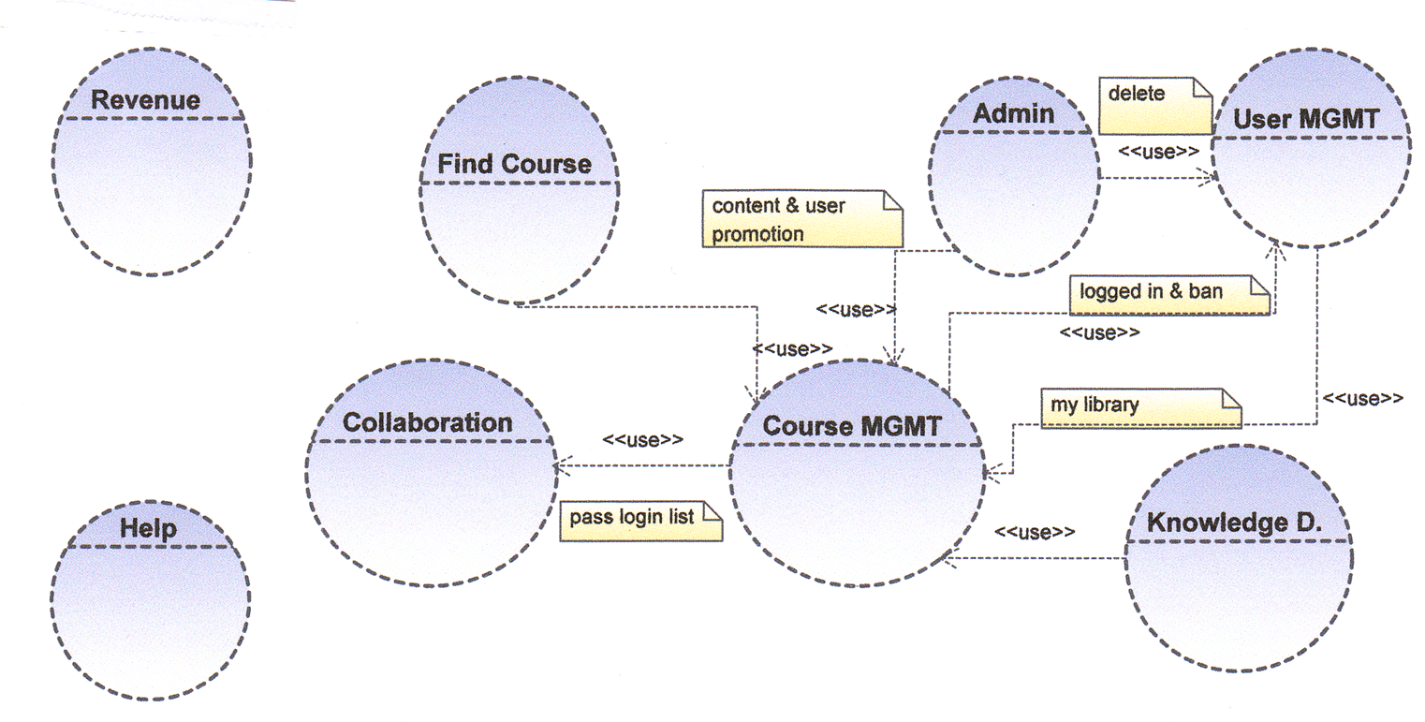

Block Diagram

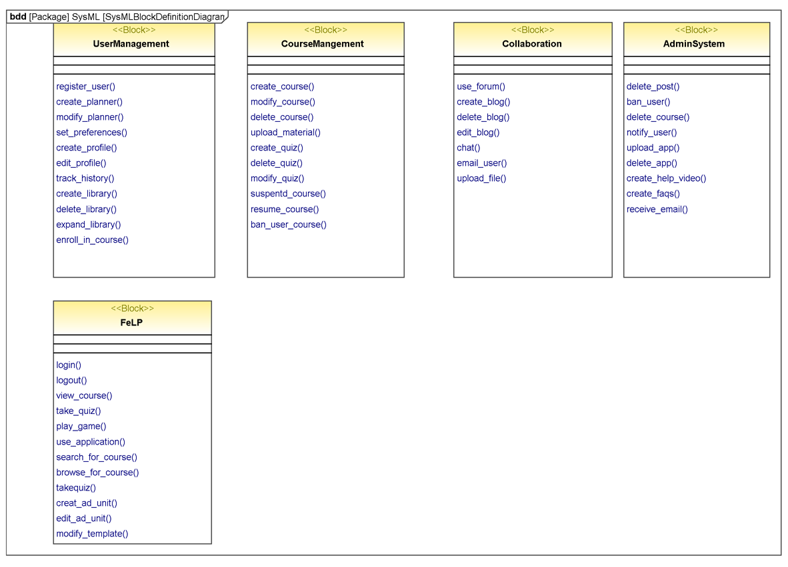

User Roles

The User Characteristics diagram below shows user characteristics represented in a hierarchical format. The entity at the top has all inherits the features of all the entities at the bottom and has certain additional features of their own. The arrow points from general to specific.

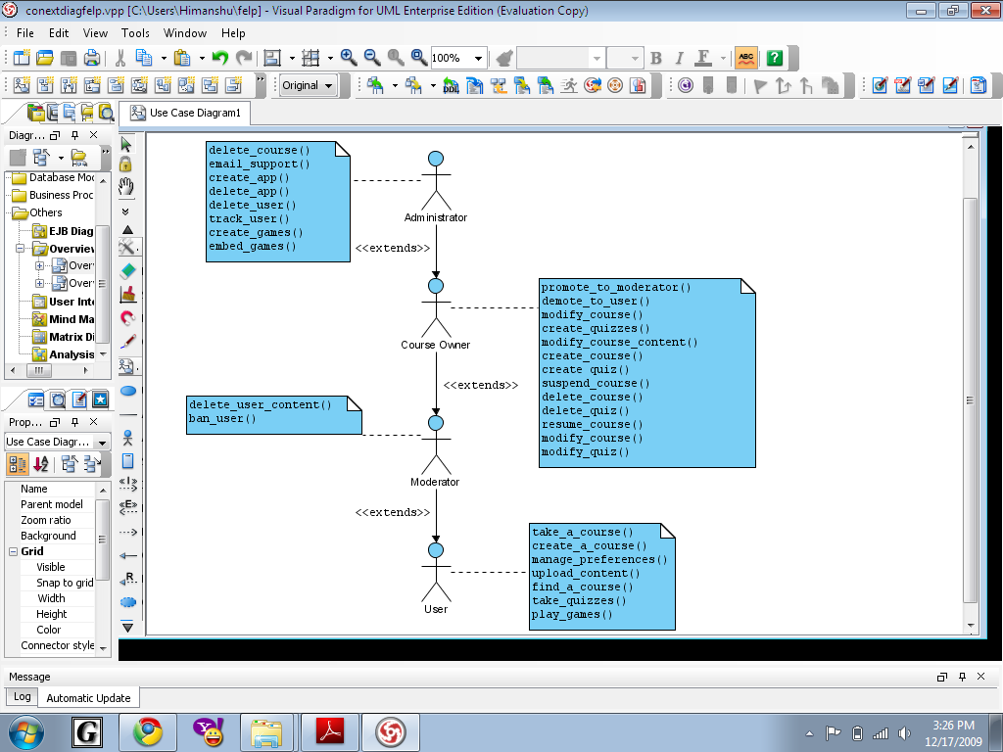

Use Case and Activity Diagrams

Primary Actor | Use Cases
User | - Register for FELPS  - Find a course  - Enroll in course  - Take the course  - Write a Blog
Course owner | - Create course  - Update course
Admin | - Delete course  - Manage Advertisements

Use cases for User Role
Use Case ID: | 00001
Use Case Name: | Register for FELPS
Created By: | Yelena Bederman |  | Last Updated By:
Date Created: | 12/02/09 |  | Date Last Updated:
Actors: |  | User
Description: |  | Register for website
Trigger: |  | User tries to view website content that is only for members. User is asked to log in or register
Preconditions: |  | User must be on ‘sign up’ page
Postconditions: |  | User is a member
Normal Flow: |  | 1.0.0 User agrees to register  1.0.1 User fills out the form  1.0.2 User agrees with rules of the website  1.0.3 User enters the code that was received by email  1.0.4 Registration completed
Alternative Flows: |  | 1.1.0 User stops registration  1.2.0 User doesn’t enter the code  1.2.1 Registration information wiped out in 24 hours
Exceptions: |  | 1.0.E.1 If user skipped some fields in the form, he/she is asked to enter missing information  1.0.E.2 If user’s email already in FELPS, stop registration process, inform the user and ask if he wants to log in
Includes: |  | After registration completed it triggers ‘Log in’ use case
Priority: |  | High
Frequency of Use: |  | Once
Business Rules: |  | n/a
Special Requirements: |  | 1. Registration form must be readable and understandable  2. Email with code must be send out in 2 minutes after completion of the form
Assumptions: |  | 1. User has an active email account  2. User knows how to type
Notes and Issues: |  | n/a

Use Case ID: | 00002
Use Case Name: | Find a course
Created By: | Yelena Bederman |  | Last Updated By: | Eric Driggs
Date Created: | 11/04/2009 |  | Date Last Updated: | 11/09/2009
Actors: |  | User
Description: |  | Actor is looking for a course in FeLPS.
Trigger: |  | User tries to search for relevant courses using the Search Engine.  User tried to narrow down his choices by browsing through the catalog using the classification hierarchy.  A link to our page was displayed in one of the search engines like Google etc.
Preconditions: |  | - User must be logged in the system  - User can connect to FeLPS web server.  - FeLPS database is online.
Postconditions: |  | - If there is no match, user is asked to redefine the search criteria  2. If there is match, the user gets a list of courses titles and their descriptions which match keywords. Results are displayed in descending relevance.
Normal Flow: |  | 2.0 Actor types a Boolean keyword search (AND, OR and NOT operations are supported, along with parentheses) into “find a course” input box.  2.0 User presses enter key, or clicks search button.  2.0 System receives query and processes it.  2.0 System returns results page.  2.0 User clicks on course link(s) to visit the course page in FeLPS.
Alternative Flows: |  | 2.1 User stops search  2.2 User clicks on Catalog link  2.2 Site returns Category page with links for each predefined category.  2.2 User chooses Category and clicks on its link.  2.2 Site returns list of Subject for that category.  2.2 User chooses Subject and clicks its link.  2.2 Site returns a list of course for that subject as well as links for topics within that subject.  2.2 User selects course and clicks its link to open course page.  2.3 User selects topic and sees courses for that topic.  2.3 User selects course and clicks its link to open course page.  2.4 User navigates away from category page at any point before clicking on a Course link.
Exceptions: |  | 2.0.E.1 User submits search with no keywords.  Display message, “please enter keyword(s) then submit search.”  2.0.E.2 Database of courses is not available.  Display message, “Courses are temporarily unavailable. Please try again later.”  2.0.E.3 Search query is below threshold size (often 3 letters) or only contains a filtered word such as the article ‘the’.  Site returns user back to search for a course page, with alert text stating “Query too short. Please enter at least one keyword at least three letters long. The following keywords are filtered: [list not-obscene filtered keywords].”  2.0.E.4 Search query returns 0 results.  Return results page with 0 results and with alert text: “No results found. Please try a different query.”  2.0.E.5 Database error or database unavailable.  Send automated email to FeLPS support email.  Return results page with 0 results and alert text: “Database error. The site admin has been notified. Please try your search again
Includes: |  | When User chooses a course it triggers “Take a course” use case
Priority: |  | High
Frequency of Use: |  | A couple of times per week
Business Rules: |  | Advertisements should be related to the search criteria
Special Requirements: |  | 1. Search engine should perform the search in short amount of time; no more than 3 seconds  2. There should be enough memory on server to list all courses for many users simultaneously.  3. The search box should be easily located and read. The search box should be easily accessible for disabled users with screen readers.
Assumptions: |  | User knows how to perform a search.  Website and Database are available and functioning properly.  User is not a bot. This is verified through login captcha.
Notes and Issues: |  | In case the search finishes without any result, send a notification to admin about the search criteria, which can be forwarded to the site owner or moderator for that course to be added in the future.

Use Case ID: | 00003
Use Case Name: | Enroll in the course
Created By: | Yelena Bederman |  | Last Updated By: | Eric Driggs
Date Created: | 12/05/2009 |  | Date Last Updated: | 12/17/09
Actors: |  | User
Description: |  | User enrolls in the course
Trigger: |  | User clicks on enroll in the course
Preconditions: |  | User must be registered and logged in
Postconditions: |  | User enrolled in the course
Normal Flow: |  | 3.0.0 User clicks on enroll in the course  3.0.1 User gets enrolled in the course
Alternative Flows: |  | n/a
Exceptions: |  | 3.0.E.1. If user already enrolled in the course, the system would give notification about it
Includes: |  | n/a
Priority: |  | High
Frequency of Use: |  | Several times a year
Business Rules: |  | N/A
Special Requirements: |  | n/a
Assumptions: |  | n/a
Notes and Issues: |  | n/a

Use Case ID: | 00004
Use Case Name: | Take the course
Created By: | Yelena Bederman |  | Last Updated By:
Date Created: | 12/02/09 |  | Date Last Updated:
Actors: |  | User
Description: |  | User takes the course; has an access to the course material (external and internal), course library, tests, educational games
Trigger: |  | User clicks on course link
Preconditions: |  | 1. User must be logged in  2 User must be enrolled in the class
Postconditions: |  | User’s progress chart updated
Normal Flow: |  | 4.0.0 User gets on the course home page  4.0.1 User chooses activity associated with the course (read articles/play games/take test, etc.)  4.0.2 User does activity  4.0.3 User can choose additional activity  4.0.4 User leaves the course page
Alternative Flows: |  | 4.1 User can resume previously saved quiz
Exceptions: |  | n/a
Includes: |  | 1. External links  2. Progress monitoring
Priority: |  | High
Frequency of Use: |  | Several times a week
Business Rules: |  | 1. External links has to be related to the course  2. Ads has to be related to the course theme
Special Requirements: |  | 1. Course material has to be timely updated  2. User may be on several course pages at the same time
Assumptions: |  | n/a
Notes and Issues: |  | n/a

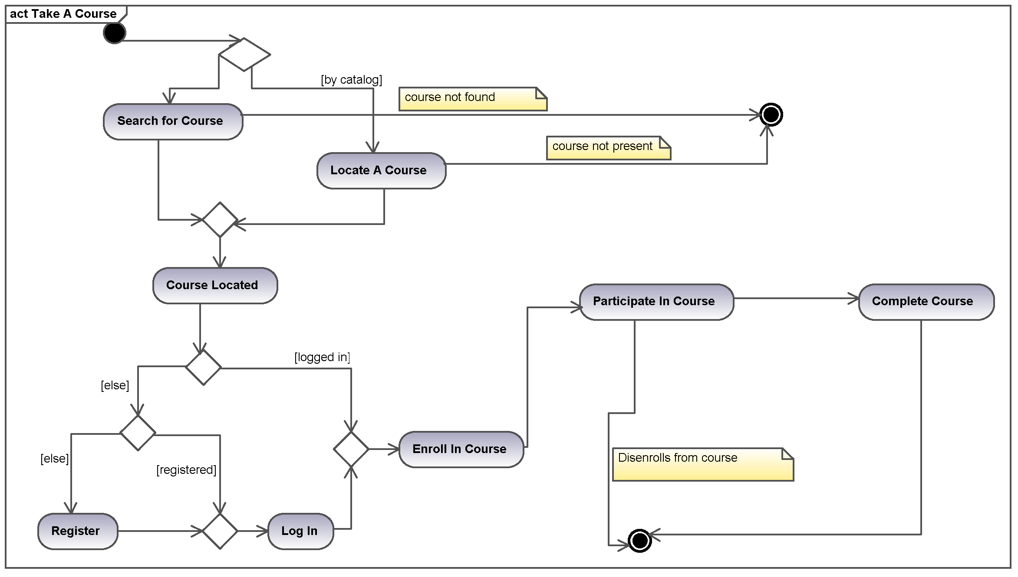

Use Case ID: | 00005
Use Case Name: | Write a Blog
Created By: | Nick Terani | Last Updated By:
Date Created: | 12/11/09 | Date Last Updated:
Actors: | User
Description: | User Writes a Blog
Trigger: | User clicks on write blog
Preconditions: | User must be on logged in  User has already created blog
Postconditions: | Blog is updated in Subject where it resides  Blog is updated in My Account page where it also resides
Normal Flow: | 5.0.0 User clicks on “my account” page  5.5.1 User clicks on “write blog” link  5.0.2 User write fills out blog form  5.0.3 User clicks submit blog  5.0.4 Blog is submitted
Alternative Flows: | 1.5.0 User enters Subject where blog resides  5.1.1 User searches for his/her blog  5.1.2 User clicks on blog  5.1.3 User clicks on edit blog  5.1.3 User fills out blog form  5.1.4 User clicks on submit  5.1.5 Blog is submitted
Exceptions: | 5.0.E.1 If user is not logged in system will prompt user to login (user must have already registered or blog could not have been created).  5.0.E.2 If user skipped some fields in the form, he/she is asked to enter missing information

Use Cases for Owner Role

Create course

Use Case ID: | 00006
Use Case Name: | Create a course
Created By: | Himanshu Sharma | Last Updated By: | Eric, Nikolas and Himanshu
Date Created: | 11/04/2009 | Date Last Updated: | 12/17/2009
Actors: | A registered FeLPS user or Administrator.
Description: | This event creates new course
Trigger: | FeLPS user uses UI to execute Create Course function.
Preconditions: | 1. User is registered and logged in to site.  2. User account has not been suspended/ deleted.
Postconditions: | 1. New course created  2. Catalog updated with new course  3. Creator of new course is course owner.  4. Course owner can now update/upload the course’s material  5. Course owner can promote other users to course moderator status.
Normal Flow: | 2.0 User uses UI to execute Create Course function.  2.0 System displays Create Course form, along with notification asking user to search to see if a similar course already exists.  2.0 User fills out Create Course form, including category, subject, course title, and description.  2.0 User submits form.  2.0 System adds course and gives confirmation message to creator.
Alternative Flows: | - Course owner clicks cancel instead of “Add this course.”  2.3 FELPS does not add course.  - User does not submit Create Course form.  2.4 FELPS does not add course.
Exceptions: | 2.0.E.1 Course owner didn’t fill out all required fields before submitting form.  An error page is returned requesting all required fields to be filled out.  2.0.E.2 Course already exists with selected title.  After the user fills in the course information, the user receives an error message that a course with the same title already exists. User may then chooses a new title and resubmit form.  2.0.E.4 System error (for example, lack of disk space) prevents course being added.  Email sent to admin. Error message is sent to user stating the course could not be created and the admin has been notified.
Includes: | N/A
Priority: | High
Frequency of Use: | N/A
Business Rules: | Course should be relevant.
Special Requirements: | Course does not violate terms of service.
Assumptions: | There is still space for new course.
Notes and Issues: | N/A

Modify a Course

Use Case ID: | 00007
Use Case Name: | Modify a Course
Created By: | Himanshu Sharma |  | Last Updated By: | Eric Driggs, Nikolas Terani, Himanshu Sharma, Yelena Bederman
Date Created: | 12/11/09 |  | Date Last Updated: | 12/17/09
Actors: |  | Course Owner/Administrator
Description: |  | Course Owner modifies his/her course, or Admin modifies any course.
Trigger: |  | Owner/Admin launches Modify Course function using UI.
Preconditions: |  | - If not admin, should be the owner of the course  - User should be logged in  - User should be on the course management page
Postconditions: |  | Course is updated.
Normal Flow: |  | 7.0 Owner/Admin launches Modify Course function from UI.  7.0 System displays Modify Course form.  7.0 Owner/Admin modifies form data.  7.0 Owner/Admin submits form.  7.0.4 System updates the course
Alternative Flows: |  | n/a
Exceptions: |  | 7.0.E.1 System Error prevents course from being modified. Email is sent to admin and user is sent notification.
Includes: |  | N/A
Priority: |  | High
Frequency of Use: |  | N/A
Business Rules: |  | Modifications do not violate terms of service.
Special Requirements: |  | N/A
Assumptions: |  | N/A
Notes and Issues: |  | N/A

Use Cases for Administrator Role

Delete course

Use Case ID: | 00008
Use Case Name: | Delete Course
Created By: | Eric Driggs |  | Last Updated By:
Date Created: | 12/11/09 |  | Date Last Updated:
Actors: |  | FeLPS Administrator or Automated Script.
Description: |  | Removes all content for course.
Trigger: |  | Automated Script, or manual deletion by Administrator.
Preconditions: |  | Administrator account is logged in to FELPS.
Postconditions: |  | 1. Course is removed from catalog.  2. Course does not appear in search.  3. Course forums, uploaded files, chat room, and other collaboration is removed.  4. Course home page does not exist.  5. Course has no owners or moderators.
Normal Flow: |  | 8.0 Administrator chooses to delete course.  8.0 System prompts administrator to confirm deletion.  8.0 System sends delete course command.  8.0 System removes course forums, uploaded files, collaboration, home page and owner and moderator status for course.
Alternative Flows: |  | 8.1 Automated script sends delete course command to system.  8.1 System removes course forums, uploaded files, collaboration, home page and owner and moderator status for course.
Exceptions: |  | 8.0.E.1 System is unable to remove some or all of course content.  Email is sent to Administrator with any error messages returned.
Includes: |  | N/A
Priority: |  | Medium
Frequency of Use: |  | Infrequent.
Business Rules: |  | N/A
Special Requirements: |  | N/A
Assumptions: |  | N/A
Notes and Issues: |  | N/A

Create Advertisement Unit
Use Case ID: | 00009
Use Case Name: | Create Advertisement Unit
Created By: | Eric Driggs |  | Last Updated By:
Date Created: | 12/17/09 |  | Date Last Updated:
Actors: |  | FELPS administrator.
Description: |  | Creates advertising unit with Ad Reseller.
Trigger: |  | FELS site templates
Preconditions: |  | FELPS has an account with Advertising Reseller.
Postconditions: |  | 1. Ad units is available for displaying ads on site pages and templates.
Normal Flow: |  | 8.0 Administrator logs in to Ad Reseller website.  8.0 Administrator creates Ad Unit by specifying dimension and formatting.  8.0 Ad Reseller site returns code to insert ad into web page or template.
Alternative Flows: |  | N/A
Exceptions: |  | N/A
Includes: |  | N/A
Priority: |  | High
Frequency of Use: |  | Infrequent.
Business Rules: |  | N/A
Special Requirements: |  | N/A
Assumptions: |  | N/A
Notes and Issues: |  | N/A
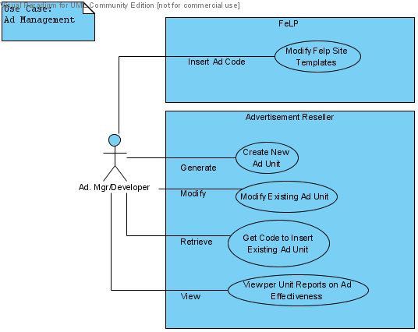

Trade study

Drupal

Overview
Drupal is a popular, modular, highly configurable, open source content management system. It has been used in many high profile sites such as WhiteHouse.gov, Eclipse.org, Ubuntu.com, Novell.com, FastCompany.com, PopularScience.com, FightHunger.org, TheOnion.com, and university sites like Harvard’s Science Department and Portland State University (pdx.edu).

Drupal comes with few features enabled by default, but additional functionality can be added through highly configurable modules, which can be either official or user contributed. When a new version is upgraded, it is likely many of the modules will also need to be upgraded.

The jack-of-all trades nature of Drupal is both a blessing and a curse. Through different modules and settings, it can be configured to act as almost any type of website. Unfortunately, with so many module dependencies and configuration options, Drupal is not difficult to break. There is also a risk that any non-official modules would not be supported in later versions.

Features

Feature | Required Modules
Course management | Organic Groups, Content Creation Kit, Taxonomy
Collaboration | Forum, Blog, Chat
Administration | No additional modules required.
User Management | Organic Groups.
Knowledge Delivery | No additional modules required.
Find a Course | Organic Groups.
Revenue Generation (ad placement in template) | No additional modules required.
Help | Help, FAQ

Experiment
As an experiment, multiple installs of Drupal were attempted, using 1) HostGator’s default fantastico settings, 2) using a preconfigured PHPEdu distribution and 3) the latest version downloaded from drupal.org. In all three instances, after enabling the modules listed in the above table, there were multiple errors and warnings when displaying site content for both users and administrators. Out of the box, creating courses was not supported.

Modular Object-Oriented Dynamic Learning Environment (Moodle)

Overview
Moodle is another Content Management System with a focus on e-learning. Its specialization and out-of the box integration makes it a very

Features

Feature | Implementation
Course management | Out of the box, fully implemented course creation, management, quizzes, etc..
Collaboration | Out of the box, fully implemented forums, chat,
Administration | Fully implemented
User Management | Fully implemented
Knowledge Delivery | Fully implemented
Find a Course | Fully implemented
Revenue Generation | N/A
Help | Fully implemented

Experiment
After changing a handful of permissions, any registered user can request and approve the creation of their own courses, after which they become the course owners. User course creation was enabled mere minutes after installation. The ease of use and simple, cohesive integrated functionality was a delightful surprise. Further use cases and scenarios should be explored, but Moodle is strongly recommended for version 1.0 of FELPS.

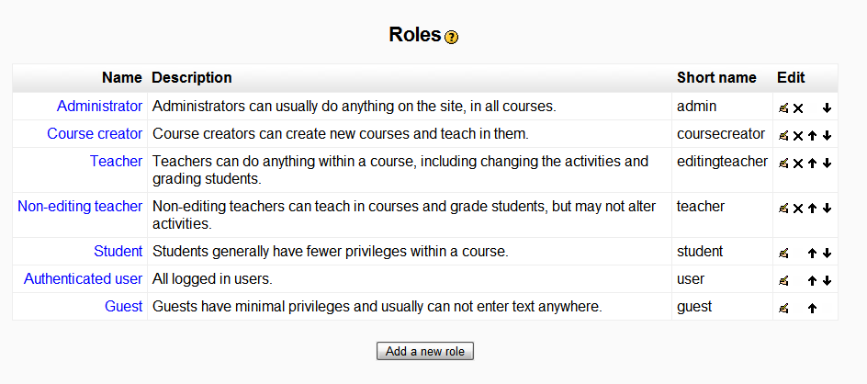
The Default User Roles in Moodle

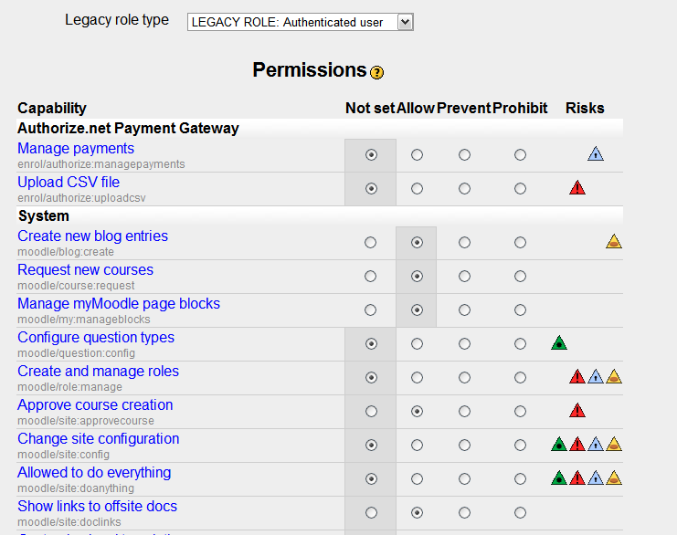

There are over 150 permission settings for functionality which can be edited for any role.
These include the ability to promote and demote users, and many of the functional requirements in the SRS.

Commercial Alternatives

Commercial software such as Blackboard has similar functionality to Moodle, but most have expensive licenses. Further investigation into such products is merited, but given the free, easy functionality provided by Moodle, it is doubtful they would be a more profitable alternative. In terms of forum software, there are more powerful forum packages like VBulletin, but integrating them into a content management system could be difficult.

Non-functional requirements

Performance

- The system shall respond to 95% of requests in fewer than 5 seconds.
- The system shall be able to support a user load up to 2,000 concurrent users on a shared web host.

Security
- Human verification systems shall be used for registration and login.
- Documents uploaded shall be virus scanned.

Usability & Accessibility
- All pages should be navigable by screen readers for the visually impaired.

Scalability

- The system shall be able to support a concurrent user load up to 8,000 concurrent users on a single dedicated web host.
- The system shall be able to support up to 30,000 concurrent users on a web cluster.

6.5 Maintainability

- Course pages shall be use a common course template, such that changes to advertising units or formatting in the template will be automatically propagated to all courses.

