Dr. Gandhi’s AIMS2 Research Project – Fall 2018 & Spring 2019
(Applicable to ALL Engineering Majors & Computer Science Majors)

Research Duration: Meetings will be held on a weekly basis and will then continue through the Spring 2019 semester. This research project will involve both face to face meetings as well as virtual meetings via skype that will expose the students to working on virtual teams, which is an absolute necessity in today’s workplace. Since this research work will be done during the regular semester, the average workload will be 5-7 hours/week.
Who is eligible: Running a technical business and developing new technical products or new code / programming products, involves much more than merely knowing how the technology works and the manufacturing/coding process to build the product/code. Understanding the involvement of the customer, how to develop a user centric product that would increase chances of the product being successful, as well as understanding the general process of product development, are all skills that make any engineer or computer scientist more competitive. Any AIMS2 student who is interested in knowing how a technical business works, is eligible to work on this project.
Faculty Contact Information: For more information about this research project, please feel free to contact Dr. Gandhi at Email: sj.gandhi@csun.edu or call at (818) 677-6157. If there is no answer, please leave a voicemail with your contact details (email or phone #) and I will call you or email you back ASAP.
Title of Project: Implementation of an Entrepreneurial Mindset for New Product Development
Research Focus: Working on this project will expose students to various aspects of product development such as Opportunity Identification, Developing Customer Awareness, Understanding target markets, user centric experiences, Determining Market Risks and understanding suppliers for Engineering Projects.
DO YOU WANT TO LEAD OR FOLLOW? IF YOU WISH TO BE A LEADER, THEN THINK OF INVESTING YOUR TIME IN CREATING AN ENTREPRENEURIAL MINDSET FOR YOURSELF AND BEING PART OF THIS PROJECT.
How does it apply to your major & why is it important?
An Entrepreneurial mindset involves creating a competitive advantage for your organization in an increasingly competitive and changing business environment that engineering firms operate in. The expectations for the engineering graduate of 2020 (which is what YOU will be) has changed considerably. Creativity will become one of the top three skills workers will need. The figure below shows the top 10 job skills that the World Economic Forum has predicted will be needed by several professions, including engineers and computer scientists!!! 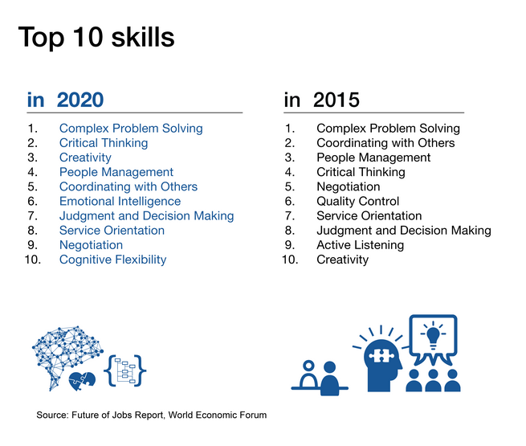
Goals of this research project, Expectations and Outcomes:
Goals:
As part of this research project, The AIMS2 students will be doing research to understand what creativity and an entrepreneurial mindset is in an industry of their choice and how to go about creating that mindset as part of new product development in the industry of their choice. This will include Opportunity Identification, Developing Customer Awareness, Determining Market Risks and obtaining funding for Engineering Projects to start and operate. Without these key initiatives, most industries would not be profitable because as an engineer or computer scientist, for any project you work on, you need to be aware of who your customer is and what their needs are ---- otherwise no one will be interested in buying your product or technology that you have spent so much time and effort working on.
Expectations & Outcomes:
The expectations for this project include the student developing an entrepreneurial mindset as part of the new product development process and understand the components of it and how it applies throughout the process. Students are expected to check in and update their faculty mentor on a weekly or bi-weekly basis on their progress in the research project so that the faculty member can provide them continuous feedback.
The final outcome will be a project report and a business model canvas related to the industry and new product chosen by the student that has to be submitted to the instructor at the end of the Spring 2019 semester. Additionally, each student / student team, will be required to create a poster to display their work and also do a 10 minute presentation at the AIMS2 research symposium that will be held in Fall 2019.

